**ATTACHMENT 2- Zoning Map**

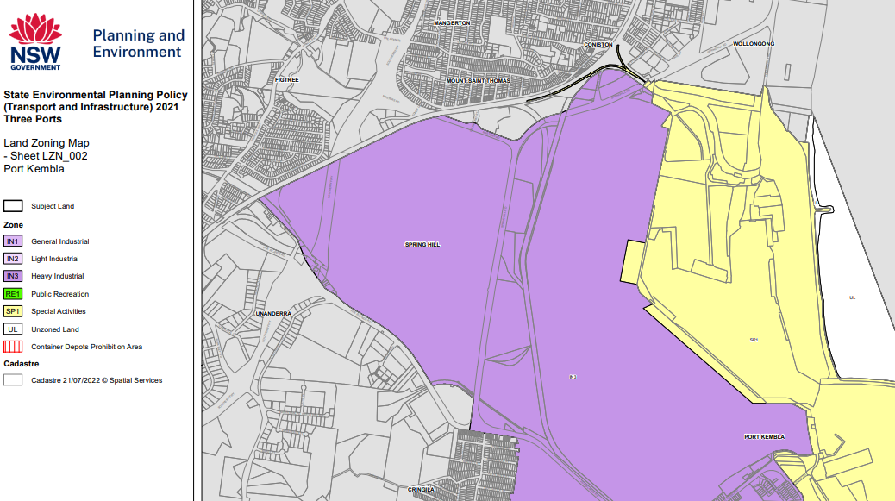

Extract from State Environmental Planning Policy (Transport and Infrastructure) 2021 Three Ports Land Zoning Map showing site outlined in red